Day of week weights

Debit PoS Payments, CH only

Data: 7.1.2019 – 24.11.2019

Monday = 1

Tuesday= 0.91

Wednesday = .97

Thursday: .97

Friday: 1.20

Saturday: 1.47

Sunday: .26

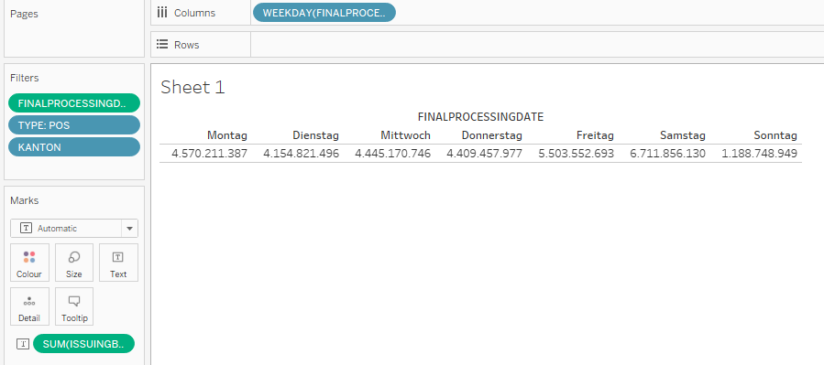

For 2020:

June:

July:

August:

September